**Cost functions /** **Metrics for Regression.**

A cost function, also known as a loss function or objective function, is a mathematical measure that evaluates the **discrepancy(error)** between predicted points and the true values or labels in the training data and serves as the basis for optimizing the model during training.

The **objective** is to **minimize the Error** by adjusting the model's **parameters (intercept cand Coefficient m)**, enabling the model to make more accurate predictions and improve its overall performance on the given task.

Here we are going to study three types of cost functions as below which are used in linear regression:

1. **MSE (Meas Square Error)**
2. **MAE (Mean Absolute Error)**

**Performance Metrix:** Performance Metrix is used to know the accuracy of the model and they tell you if you're making progress or not. Here we will discuss two types of performance metrics.

1. **MSE (Meas Square Error)**
2. **MAE (Mean Absolute Error)**
3. **RMSE (Root Means Square Error)**
4. **R Square**
5. **Adjusted R Square**

**Mean Squared Error:**

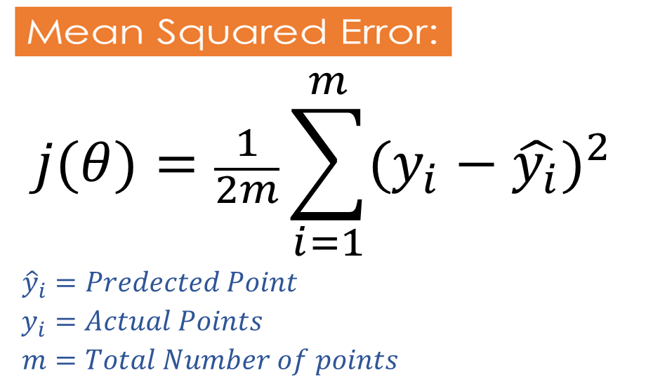

MSE works by calculating the squared differences between each predicted value and the corresponding actual value, summing them up, and then dividing them by the total number of data points.

By squaring the differences, negative and positive errors are both considered, and larger errors are penalized more heavily, giving more weight to larger deviations between predictions and actual values.

MSE is particularly popular due to its mathematical properties, including convexity, which makes it easier to optimize when training machine learning models.

However, it is sensitive to outliers and may not be an ideal metric in cases where the data is **heavily skewed or contains heteroscedasticity** (varying levels of error across the range of the target variable).

A lower value of MSE indicates that the model's predictions are closer to the actual values, and thus, a lower MSE is desirable as it signifies better model performance.

|  |  |
| --- | --- |
| Advantages | Disadvantages |
| - This equation is differentiable (differentiable is required to calculate slope, to update the **θ0**and **θ1** )  - This equation creates a convex function.  - Since this function creates a convex function, it has one global minimum | - Since residuals are penalized by squaring it up, it is not robust to Outliers.  - No Unit of Measurement: MSE is expressed in the square of the units of the target variable, which can make it difficult to relate to the original data units. |

**Mean Absolute Error:**

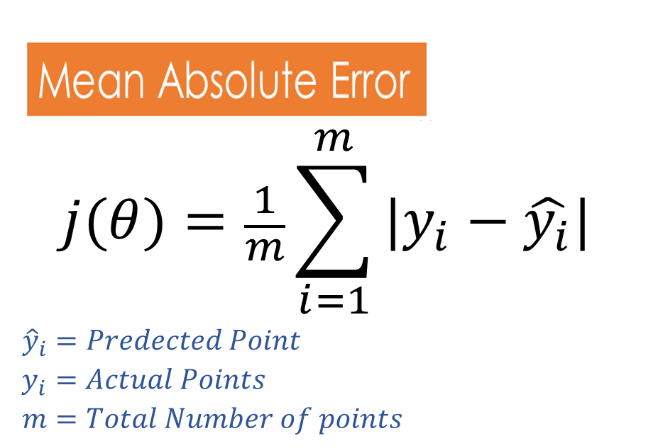

MAE works by taking the absolute difference between each predicted value and the corresponding actual value, summing them up, and then dividing by the total number of data points.

MAE does not square the differences between predicted and actual values. This means that MAE treats positive and negative errors equally and does not penalize larger errors more heavily.

MAE is particularly useful in scenarios where outliers may have a significant impact on the model's performance. Since it takes the absolute value of the errors, extreme deviations between predictions and actual values do not have an inflated effect on the overall MAE value.

This function uses the subgradient concept to calculate the derivative.

|  |  |
| --- | --- |
| Advantages | Disadvantages |
| - Robust to outliers  - Remains in the same unit, since residuals are not penalized by squaring it. | - Conversion takes usually takes a lot of time since the same unit is used.  - Optimization is usually a complex task |

**Root Mean Squared Error**

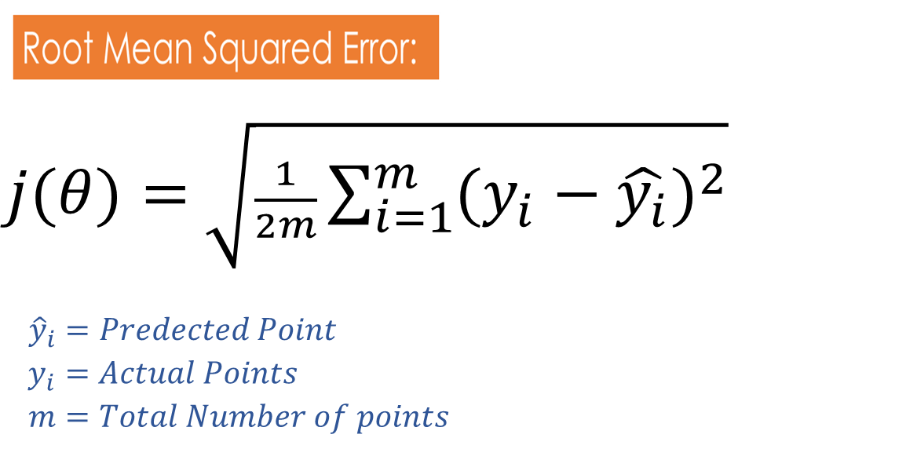

RMSE is similar to Mean Squared Error (MSE), but RMSE is taken as the square root of MSE to make the units of the error metric consistent with the original target variable. By taking the square root, RMSE is in the same unit as the target variable, making it more interpretable and easier to compare with the scale of the original data.

It penalizes larger errors more heavily, giving a higher weight to larger deviations between predictions and actual values.

|  |  |
| --- | --- |
| **Advantages** | **Disadvantages** |
| - Sensitivity to Large Errors: RMSE gives higher weight to larger errors due to squaring the differences between predicted and actual values. This sensitivity makes it suitable for applications where large errors are more critical and need to be penalized appropriately.  - RMSE is widely used and easy to understand. The metric is expressed in the same units as the target variable, which makes it more interpretable and relatable to the problem domain. | - Since residuals are penalized by squaring it up, it is not robust to Outliers. |

**R Square**

R-squared(r2 Square), also known as the coefficient of determination, is a performance metric used to evaluate the goodness of fit of a linear regression model. It provides an indication of how well the model explains the variation in the dependent variable based on the independent variables.

R-squared is a value between 0 and 1. A value of 0 indicates that the model does not explain any of the variability in the dependent variable, while a value of 1 indicates that the model perfectly explains all the variability.

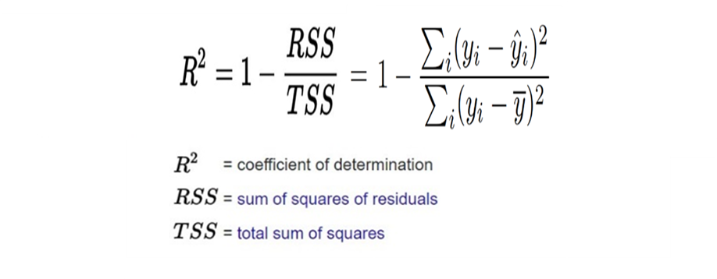



**Adjusted R Square:**

There may be instances where certain features within a model are not correlated with the output feature. Logically, these features should decrease the accuracy of the model, but in reality, they actually improve the accuracy. This can lead to an unclear understanding of the model's performance and can result in poor real-time performance if deployed. To avoid such scenarios, the "adjusted R squared" formula is used. This ensures that the accuracy of the model decreases when non-correlated features are added and these features are removed during the training phase.

Adjusted R-squared is a modified version of the R-squared (coefficient of determination) that takes into account the number of independent variables in the model. It is used to assess the goodness of fit of a regression model while penalizing the inclusion of unnecessary independent variables.

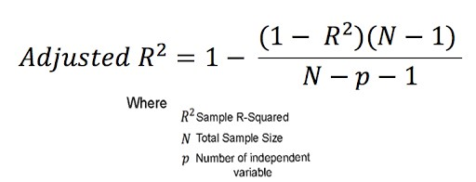

**Overfilling and Underfitting (Bias and Variance):**

**Bias :** Accuracy of the training data is mentioned by Bias.  
**Variance:**accuracy of the test data is mentioned by Variance.

**Low Bias :**if Training Data has Very Good Accuracy then it is Low Bias.  
**High Bias :**If Training Data has Bad Accuracy then.

**Low Variance:** if Testing Data Very Good Accuracy.

**High Variance:** if Testing Data Bad or Good Accuracy.

**Overfitting:**

If training Data has Very Good Accuracy(Low Bias) while Testing Data has Bad Accuracy (High Variance) then this condition is called overfitting. To solve such a problem need to perform hyperparameter tuning.

**Underfitting :** If training Data has Very Bad Accuracy(High Bias), while Testing Data has Bad (High Variance) or Good Accuracy (Low Variance) then this condition is called Underfitting.

|  |  |  |
| --- | --- | --- |
| **Mean Squared Error (MSE)**: | **Mean Absolute Error (MAE)**: | **Root Mean Squared Error (RMSE)**: |
| MSE measures the average of the **squared** differences between predicted and actual values. | MAE measures the average of the **absolute** differences between predicted and actual values. | RMSE is the square root of the MSE and shares similar characteristics but is in the same units as the target variable. |
| It squares the errors, penalizing larger errors more heavily than smaller errors. | It does not square the errors, thus treating all errors equally regardless of size. | RMSE provides a measure of the average magnitude of errors, with the advantage of being in the original units of the target variable. |
| Because of squaring, MSE is sensitive to outliers. | MAE is less sensitive to outliers compared to MSE. | Like MSE, RMSE is also sensitive to outliers. |
| It's useful when you want to penalize larger errors more significantly or when you're interested in the variance of the errors. | It's useful when you want a metric that's more interpretable and less influenced by outliers. | It's useful when you want to interpret the average error magnitude in the original units of the target variable. |
| MSE is a convex function. It has a single, global minimum, which means that any local minimum is also the global minimum. | MAE is not strictly convex, but it can be considered convex for practical purposes. It is piecewise linear with multiple linear segments. | RMSE also has a convex function. It has a single, global minimum, which means that any local minimum is also the global minimum. |
| Unlocking the Power of Concave and Convex Functions in Machine… – Towards AI | Unlocking the Power of Concave and Convex Functions in Machine… – Towards AI | Unlocking the Power of Concave and Convex Functions in Machine… – Towards AI |